Chapter 6 Exercise

p/s: Different than the book, have to check the notes

C:\Users\ChienSienLow\Desktop\2.PNG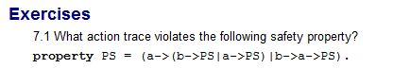C:\Users\ChienSienLow\Desktop\4.PNG